Experiment 11

1. Write a java program to establish a connection to database and print connection successful if the connection is established.

import java.sql.*;

public class JDBCConnection {

public static void main(String[] args) {

// TODO Auto-generated method stub

String url = "jdbc:oracle:thin:@localhost:1521:orcl"; //System

String username = "mca";

String password = "mca";

try {

Class.forName("oracle.jdbc.driver.OracleDriver");

// DriverManager.registerDriver(new oracle.jdbc.driver.OracleDriver());

Connection conn = DriverManager.getConnection(url, username, password);

System.out.println("Connection successful");

conn.close();

}catch(Exception e) {

System.out.println("Connection failed");

e.printStackTrace();

}

}

}

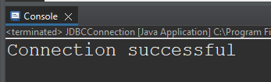

1. Write a java program : create employee table with fields emp_name, emp_id, age, department, salary.

import java.sql.*;

public class CreateTableEmployee {

public static void main(String[] args) {

// TODO Auto-generated method stub

String url = "jdbc:oracle:thin:@localhost:1521:orcl";

String username = "mca";

String password = "mca";

String query = "CREATE TABLE EMPLOYEE( ID NUMBER(5) PRIMARY KEY,"

+ " NAME VARCHAR2(50), DEPARTMENT VARCHAR2(3), AGE NUMBER(2), SALARY NUMBER(6))";

try {

Class.forName("oracle.jdbc.driver.OracleDriver");

Connection conn = DriverManager.getConnection(url, username, password);

Statement stmt = conn.createStatement();

stmt.execute(query);

System.out.println("Table 'Employee' created successfully");

stmt.close();

conn.close();

} catch (ClassNotFoundException e) {

// TODO Auto-generated catch block

e.printStackTrace();

} catch (SQLException e) {

// TODO Auto-generated catch block

e.printStackTrace();

}

}

}

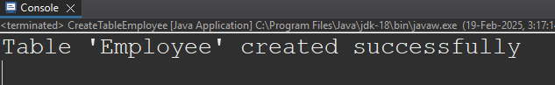  
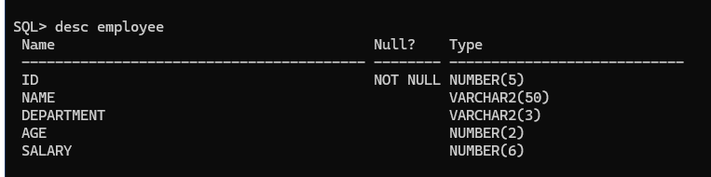

1. Write a java program to retrieve and print all the data from employee table.

import java.sql.*;

public class ViewEmployeeTable {

public static void main(String[] args) {

// TODO Auto-generated method stub

String url = "jdbc:oracle:thin:@localhost:1521:orcl";

String username = "mca";

String password = "mca";

String query = "SELECT * FROM EMPLOYEE1";

// String query = "insert into employee values(3, 'Mani', 'Library', 27, 67000)";

try {

Class.forName("oracle.jdbc.driver.OracleDriver");

Connection con = DriverManager.getConnection(url, username, password);

Statement stmt = con.createStatement();

stmt.execute(query);

ResultSet resultSet = stmt.getResultSet();

while(resultSet.next()) {

System.out.println("ID: "+resultSet.getInt(1)+ " | Name: "+resultSet.getString(2)

+ " | Department: "+ resultSet.getString(3)+ " | Age: " + resultSet.getInt(4)+

" | Salary: " + resultSet.getLong(5));

}

con.close();

}catch(Exception e) {

e.printStackTrace();

}

}

}

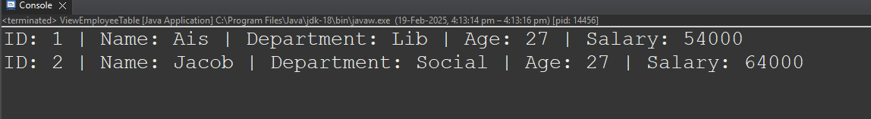

1. Write a java program to update employee salary base on their id.
2. Write a java program that uses PreparedStatement to securely insert, update, or delete employee records.
3. Login system- compare with a random employee detail.